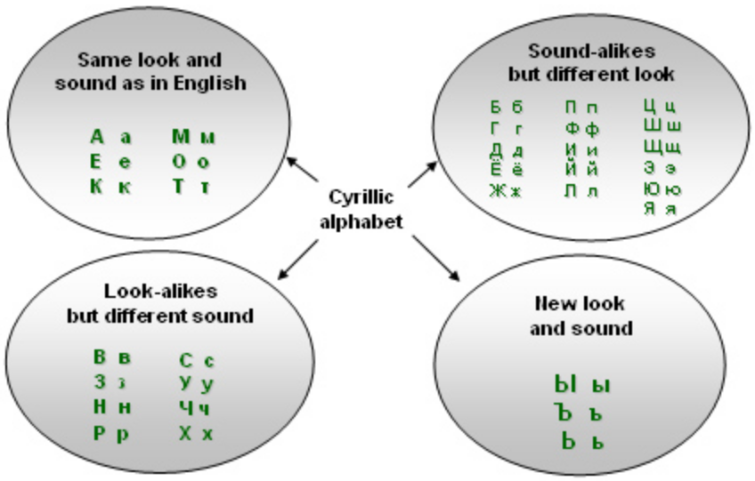

Russian letters that are (almost) the same.
А а - Pronounced like the "a" in the word "father" or "car". It is not the 'flat' "a" sound you sometimes hear in words like "cat" or "flat".
К к - Pronounced like the "k" in "kitten" or "kangaroo". This letter replaces the english "c" sound in words like "cat".
М м - Pronounced like the "m" in man. (Note: Unlike english, the hand-written "м" should always start from the bottom)
O o - Pronounced like the "o" in "bore" (stressed) "a" in "Sand". (unstressed)
Т т - Pronounced like the "t" in "tap". (Note: The hand-written (and italic) form is "т". It should always start from the top, as it looks quite similar to the letter "м")

Russian letters that look like english letters but sound different.
(These are the most important to learn so you don't get them mixed up.)
В в - Pronounced like the "v" in "vet". (Equivalent to the english letter "v").
Е е - Pronounced like the "ye" in "yes" (stressed) or "yi" in "yipi" (unstressed, at beginning of word, or after vowel) or "i" in "gin" (unstressed after consonant).
Н н - Pronounced like the "n" in "no". (Equivalent to the english letter "n").
Р р - Pronounced like the "r" in "run", but it is rolled. (Equ. to the english letter "r", greek rho).
С с - Pronounced like the "s" in "see". (Equivalent to the english letter "s"). (It might help to remember that it's used like the "s" sound in the english words "centre" and "cent".)
У у - Pronounced like the "u" in "boot" or "root".
Х х - Pronounced like the "h" in "hello". However, this is often pronounced more like the "ch" in the Scottish "Loch" or German "Bach", or the mexican pronunciation of "x" in "Mexico".

Russian letters that look unusual, but have familiar sounds
Б б - Pronounced like the "b" in "bat". (Equivalent to the english letter "b").
Г г - Pronounced like the "g" in "go". (Equivalent to the english letter "g", greek gamma).
Д д - Pronounced like the "d" in "dog". (Equivalent to the english letter "d", greek delta).
З з - Pronounced like the "z" in "zoo". (Equivalent to the english letter "z").
И и - Pronounced like the "i" in "taxi". (Sometimes equivalent to the english letter "i", the short 'ee' sound.). (Note: The hand-written form for "и" looks a little like the english "u").
Л л - Pronounced like the "l" in "love". (Equivalent to the english letter "l").
П п - Pronounced like the "p" in "pot". (Equivalent to the english letter "p", greek pi).
Ф ф - Pronounced like the "f" in "fat". (Equivalent to the english letter "f", greek phi).
Э э - Pronounced like the "e" in "fed" (stressed) or "i" in "gin" (unstressed).

New Russian letters and sounds
(The sounds will be familiar, but they don't have their own letter in English).
Ю ю - Pronounced like the "yu" in "universe". (Pronounced much like the english word "you").
Я я - Pronounced like the "ya" in "yard" (stressed) or "yi" in "yipi" (unstressed, at beginning of word, or after vowel) or "i" in "gin" (unstressed after consonant).
Ё ё - Pronounced like "yo" in "yonder". (Note: In modern Russian you may find this letter simply written as Е е.)
Ж ж - Like "sch" in "Asche", "s" in "measure", "pleasure" or "fusion" or like "g" in colour "beige". (As there is no english symbol for this sound, it is usually represented as "zh")
Ц ц - Similar to the "ts" sound in "sits" or "its".
Ч ч - Pronounced like "tsch" "Tschutten", the "ch" in "chips" or "church" .
Ш ш - Pronounced like "sch" in "schwimmen" the "sh" in shut.
Щ щ - Pronounced like "sch" in "schwimmen", "sh" but with your tongue on the roof of your mouth. Try putting your tongue in the same position as you would to say "ch" but say "sh" instead. English speakers may find it hard to define the difference between "ш" and "щ".
Ы ы - Pronounced like the "y-i-ü" like "i" in "ill". (Said with your tongue slightly back in your mouth.)
Й й - This letter is used to form diphthongs. Pronounced "j" like "Judo".So "oй" is like the "oy" sound in "boy" or "aй" is like the "igh" in "sigh".

Pronunciation Symbols
(These letters have no sound on their own, but are still considered letters.).
Ъ ъ - The 'Hard Sign' is rarely used. It indicates a slight pause between sylables.
Ь ь - The 'Soft Sign' makes the previous letter 'soft'. Think of the "p" sound in the word "pew". (Try inflecting a very slight "y" sound onto letter before it.)

A note about vowels
You may have noticed that there are often two forms of a vowel, hard and soft. It may help to note the corresponding vowels.
А a ("a") | Я я ("ya" (stressed)  "yi" (unstressed, at beginning of word or after vowel)  "i" (unstressed after consonant))
Э э ("e" (stressed)  "i" (unstressed)) | Е e ("ye" (stressed)  "yi" (unstressed, at beginning of word or after vowel)  "i" (unstressed after consonant))
О o ("o" (stressed)  "a" (unstressed)) | Ё ё ("yo")
У y ("u") | Ю ю ("yu")
Ы (y-i-ü)
И (i)
Й (j)

Quick reference on "hard-indicating" vowels
Russian letter | Symbol | Pronunciation
A (stressed) | ah | as Ah, but shorter
A (unstressed) | a | as u in but
O (stressed) | o | as aw in law
O (unstressed) | a | as u in but
Ы | ü/i | no English equivalent
У | oo | as oo in wood
Э | e | as e in pet

Quick reference on "soft-indicating" vowels
Russian letter | Symbol | Pronunciation
Я (stressed) | ya | as ya in yahoo
Я (unstressed) | ee | as ee in meet, but very short
Е (stressed) | ye | as ye in yes
Е (unstressed) | ee | as ee in meet, but very short
Ё (always stressed) | yo | as yo in yolk
Ю | yoo | as the word you
И (stressed) | ee | as ee in meet

Pronunciation of O in unstressed positions is already explained in When is the Russian letter O pronounced as A:
- молоко [malako]
- Москва [maskva]
- золото [zolata]
Russian letters Я, Е, Э are pronounced like an abbreviated Russian И when unstressed:
- эгоист [ee-guh-EEST]
- эпоха [ee-POH-khuh]
- мясной [mees-NOY]
- весёлый [vee-SYOH-liy]
- телефон [tee-lee-FOHN]
When an unstressed Я, Е happens in the beginning of a word or after a vowel, the й-sound is added and they are pronounced йи [yee]:
- яичница [yee-EESH-nee-tsuh]
- Ямайка [yee-MAI-kuh]
- еда [yee-DAH]

